**HCIA-DATACOM**

1) OSI Model

2) WLAN

3) WAN

4) SDN

5) Application Layer Protocols

6) AAA

7) STP

8) VLAN

9) Network Management O&M

10) Network Layer Protocol

11) IPV6

12)ACL

13) Static & Dynamic Routes

14) Switching

**1) OSI MODEL**

21. Which of the following lists the correct protocol layers of the TCP/IP reference model from bottom to top?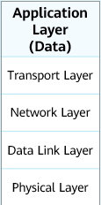

A. Physical layer, data link layer, network layer, transport layer, session layer, presentation layer, and application layer

**B. Physical layer, data link layer, network layer, transport layer, and application layer**

C. Application layer, presentation layer, session layer, transport layer, network layer, data link layer, and physical layer

D. Application layer, transport layer, network layer, data link layer, and physical layer

47.In the OSI reference model, what can complete end-to-end error detection and flow control?

A. Physical layer

B. Data link layer

C. Network layer

**D. Transport layer**

139.Which layer of the OSI reference model does the router work at?

A. Data link layer

B. Transport layer

C. Application layer

**D. Network layer**

145.On which layer of the OSI reference model does the Ethernet switch work?

A. Network layer

**B. Data link layer**

C. Physical layer

D. Transport layer

233. The OSI reference model from high-level to bottom-level is.

A. Application layer, transport layer, network layer, data link layer, physical layer

B. Application layer, session layer, presentation layer, transport layer, network layer, data link layer, physical layer

C. Application layer, presentation layer, session layer, network layer, transport layer, data link layer, physical layer

**D. Application layer, presentation layer, session layer, transport layer, network layer, data link layer, physical layer**

**3) WLAN**

5. WLAN technology enables transmission of information by radio waves over the air. Currently, the 2.6 GHz and 5 GHz frequency bands are used.

* True
* **False**

**Correct: 2.4 GHz or 5 GHz**

344. Which of the following IEEE802.11 standards only supports 2.4GHz frequency band for communication? 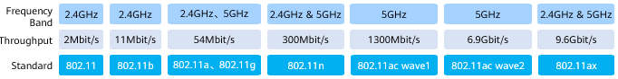

A.802.11a

**B.802.11g**

C.802.11ax

D.802.11n

211. Which of the following IEEE 802.11 standards support operation in the 5GHz frequency band? (Multiple choice)

**A.802.11ac**

**B.802.11n**

C.802.11g

**D.802.11a**

186. In the WLAN network architecture, what is terminal equipment that supports the 802.11 standard called?

A.Client

B.AC

**C.STA**

D.AP

18. Which WLAN security policies support the link authentication method of Open mode? (Multiple Choice) 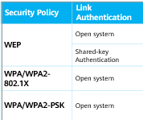

**A.WPA2-802.IX**

**B.WPA2-PSK**

C.WEP

**D.WPA**

210. What are the user authentication methods that can be deployed in wlan? (Multiple choice)

**A. Portal authentication** 

**B. MAC authentication**

C. Radius certification

**D. 802.1X authentication**

213. Broadly speaking, which of the following does the transmission medium that constitutes the wireless local area network wlan not include?

**A. Ray**

B. Radio waves

C. Infrared

D. Laser

60. The Layer 2 networking of WLAN means that the STA uses the AC as its gateway.

**A.True**

B.False

17. A WLAN is constructed using wireless technologies. Which of the following statements about the WLAN networking is false?

1. A basic service set (BSS) indicates an area covered by an AP.
2. The basic service set identifier (BSSID) identifies a wireless network and is represented using the MAC address of an AP.
3. **A virtual access point (VAP) is a service entity virtualized on an AP. All VAPs virtualized on the same AP has the same BSSID.**
4. The service set identifier (SSID) identifies a wireless network and is represented using a character string.

18. Various profiles are designed to facilitate the configuration and maintenance of WLAN functions and features. Which of the following statements about these profiles is false?

1. VAP profiles provide differentiated WLAN services for users.
2. **Only security profiles and SSID profiles can be bound to VAP profiles.**
3. Regulatory domain profiles provide configurations of the country code, calibration channel set, and calibration bandwidth for APs.
4. Radio profiles are used to optimize radio parameters and control the in-service channel switching function.



57. A WLAN is a network that uses wireless signals such as radio waves, lasers, and infrared rays to replace the traditional media used for transmission on a wired LAN. Which of the following devices are commonly used on a WLAN?

**A. Fit AP**

**B. Cloud AP**

**C. Wireless access controller (AC)**

**D. Fat AP**

401. What equipment is generally involved in the wlan deployment scheme in the enterprise scenario? (Multiple choice)

**A. AC(Access Controller)**

**B. Poe switch**

C. CPE

**D. AP**

12. A WLAN is constructed using wireless technologies. Which of the following are wireless network types based on the application scope?

1. **WMAN**
2. **WLAN**
3. **WPAN**
4. **WWAN**

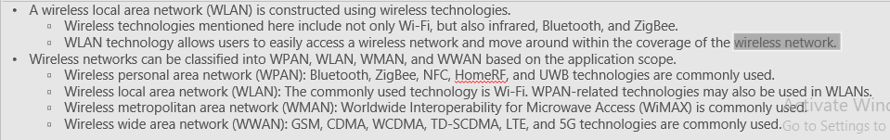

* **AC & AP**

1. In the WLAN network architecture, ACs can be connected in in-path or off-path mode.

* **True**
* False

12. Which of the following statements is true about APs in WLAN networking?

A Fit APs can independently implement functions such as wireless user access, service data encryption, and service data packet forwarding.

B. An AC must be deployed in WLAN networks.

**C. Typically, APs use PoE power to facilitate deployment.**

D. Fat APs need to work with an AC and are managed and configured by the AC in a unified manner.

22. The process for an AP to go online is as follows: The AP sends a Join Request packet to an AC, which then authenticates the AP after receiving the packet, The AP gets managed after being successfully authenticated. Which of the following AP authentication methods is not supported by an AC?

A MAC address authentication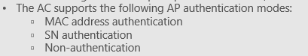

**B. Password authentication**

C. Non-authentication

D. Serial number(SN) authentication

16.In IPv4 networks, AP supports static and DHCP methods to obtain IP addresses.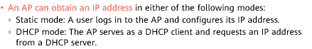

**A.True**

B.False

14.When AP and AC are on different Layer 3 networks, what method is recommended for AP to discover AC? (Multiple Choice)

A. Broadcasting method

**B. DNS**

**C. DHCP**

D. Manually specified on AP



130.How to add AP on AC? (Multiple Choice)

A. Add online

**B. Automatically discover AP**

**C. Import AP offline**

**D. Manually confirm APs in the uncertified lis**t



337. What is the coverage area of an AP in WLAN?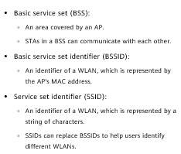

**A. BSS**

B. SSID

C. BSSID

D.ESS

268. What is the data link layer MAC address of each VAP on the AP?

A.SSID

B.BSS

C.ESS

**D.BSSID**

131. Which of the following messages is used by AP to request a software version from AC?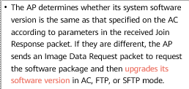

A.VRP System Request

B.Software Request

**C.Image Data Request**

D.Image package Request

48.Which of the following are possible causes for an AP's failure to go online?

**A. The AC version does not match the AP version.**

**B. The link between the AC and AP is not established.**

**C. PoE parameters are incorrectly configured on the PoE switch to which the AP is connected.**

**D. Network cables are not properly connected.**

338. FIT AP can work independently without relying on AC.

A.True

**B.False**

84. FAT AP can independently complete wireless user access, wireless user authentication, and business data forwarding without AC.

**A.True**

B.False



* **CAPWAP**

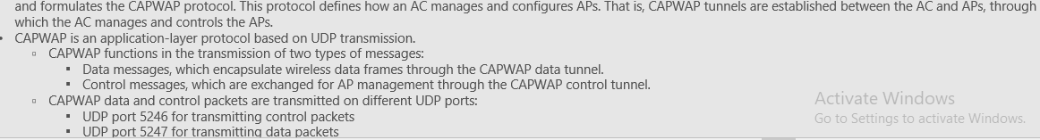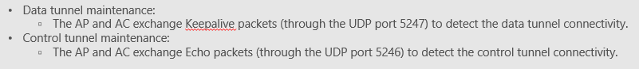

1. Which of the following statements is false about Control and Provisioning of Wireless Access Points (CAPWAP)?

**A. CAPWAP is an application layer protocol based on TCP.**

B. CAPWAP transmits two types of messages at the transport layer: service data traffic and management traffic.

C. When tunnel forwarding is used, an AP exchanges data with an AC through a CAPWAP tunnel.

D. CAPWAP is used to maintain the connectivity between APs and an AC.

12. A CAPWAP tunnel is established between the Fit AP and AC to transmit management traffic and service data traffic.

* True
* **False**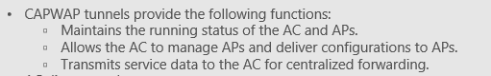

29. Which of the following statements about Fit AP+AC networking is true?

A. After a CAPWAP tunnel is established between the AC and Fit AP keep alive packets are used to detect the status of the CAPWAP tunnel.

**B. A data tunnel and a control tunnel will be established between the AC and Fit AP**.

C. The tunnel forwarding mode can reduce the forwarding pressure on the AC.

D. The AP version can be upgraded through HTTP.

300. In the WLAN architecture, the FIT AP cannot work independently and needs to be managed by the AC. Which of the following protocols are used to communicate between FIT AP and AC?

A. IPsec

B.WEP

**C.CAPWAP**

D.WAP

301. What is the first operation performed by the FIT AP after obtaining the AC's IP address?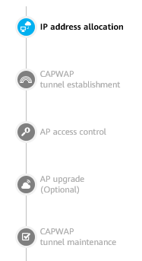

A. Upgrade software version

B. Download the configuration file

**C. Establish CAPWAP tunnel**

D. Request configuration file

336. AC uses CAPWAP control tunnel to transmit management messages to FIT AP.

**A.True**

B.False

335. On the AC, you can manually specify the source address or source interface of the CAPWAP tunnel.

**A.True**

B.False

36. An AC manages and controls APs in a centralized manner through CAPWAP tunnels. An AP sends a Discovery Request packet to find an available AC. Which of the following methods cannot be used by an AP to discover an AC?

A. DNS

**B. Multicast**

C.DHCP

D. Static configuration (manually specifying an AC)

37. Which of the following is not a method for an AP to discover an AC address?

A. Broadcast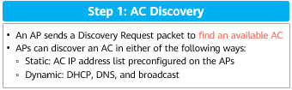

B. DNS.

C. DHCP

**D. OSPF**

E. Static configuration

* CAMPUS NETWORK

24.In the campus network, network reliability can be improved by using link aggregation and stacking technology.

**A.True**

B.False

**4) WAN**

* **PPP (Point-to-Point Protocol)**

154. The command to enable CHAP authentication in PPP is: ppp chap authentication.

A. True 

**B. False**

51.On interfaces that use PPP as the data link layer protocol, you can configure static routes by specifying the next hop address or outbound interface.

**A.True**

B.False

247. What is the value of the Flag field in the PPP frame format?

A. OxFF (Address Field)

**B. Ox7E (Flag Field)**

C. OxEF

D. Ox8E



291_ In the process of establishing a PPP link, which phase can be directly converted into by the Dead phase?

A. Authenticate

**B. Terminate**

C. Establish

D. Network

584. In the LCP negotiation phase of lhe PPP protocol, if the parameters sent by the other party are completely accepted, which of the following packets will be sent?

A. Configure-Reject

**B. Configure-Ack**

C. Configure-Request

D. Configure-Nak

11. Which of the following statements is true about the PPP configuration and deployment?  
A. PPP cannot be used to deliver IP addresses.  
**B. PPP supports both CHAP and PAP authentication.**  
C. PPP cannot change the keepalive time.  
D. PPP does not support bidirectional authentication.

30. The Point-to-Point Protocol (PPP) is a common data link layer protocol for wide area networks (WANs). Which of the following statements about PPP is false?

A. If PPP uses password authentication mode, negotiation packets are transmitted in plain text, which is insecure.

B. PPP uses the Link Control Protocol (LCP) to negotiate link control layer parameters.

**C. The establishment of a PPP link goes through three phases. link layer negotiation, network layer negotiation, and authentication.**

D. PPP supports the Password Authentication Protocol (PAP) and Challenge-Handshake Authentication Protocol (CHAP).

605. Which of the following value is used in the Protocol field in the PPP frame to indicate that the core is an IP packet? 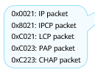

A. 0x8821

**B. 0x0021**

C. Ox8021

D. 0x8863

44. The Protocol field in the PPP frame format is OxC223, indicating that the protocol is:

**A. CHAP**

B. PAP

C. NCP

D. LCP

**Protocol Packets i.e. (0XC021, 0XC023, 0XC0223 indicate LCP, PAP, CHAP packets respectively).**

327. The Protocol field in the PPP frame format is 0xCO23, indicating that the protocol is?

**A. PAP**

B. LCP

C. CHAP

D. NCP

501_ Which of the following functions are supported by the LCP protocol in the PPP protocol? {Multiple choice)

A. Negotiate the maximum receiving unit MRU

**B. Negotiate the authentication protocol**

C. Negotiate the network layer address

**D. Detect link loops**

394. Which of the following are the advantages of the PPP protocol? (Multiple choice)

**A. PPP protocol supports negotiation of link layer parameters**

**B. PPP protocol supports negotiation of network layer parameters**

**C. PPP protocol supports both synchronous transmission and asynchronous transmission.**

**D. PPP protocol supports authentication**

672 If the Authenticator sends the wrong username and password to the Authenticator during The PPP authentication process, what type of message will the Authenticator send to the Authenticator? 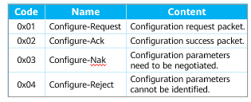

A. Authenticate-Reject

B. Authenticate-Ack

**C. Authenticate-Nak**

D. Authenticate-Reply

* **PPPoE (Point-to-Point Protocol over Ethernet)**

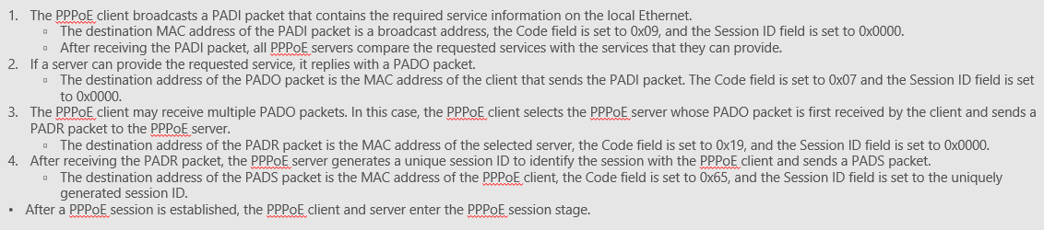



46. Which method does the PPPoE client use to send PADI packets to the Server?

**A. Broadcast**  
B. Unicast

C. Multicast

D. Anycast

472. Which of the following PPPoE messages are sent non-unicast?

A. PADS

**B. PADI**

C. PADO

D. PADR

393. Which message need to send when needing to terminate a PPPoE session?

A. PADR

**B. PADT**

C. PADO

D. PADI

102. Which of the following values is used in the Length type field of the Ethernet data frame, indicating that the packet is in the PPPoE discovery phase?

A. 0x0800

**B. 0x8863**

C. 0x8864

D. 0x0806

- 0x8863 indicates PPPoE discovery packets are carried

- 0x8864 indicates PPPoE session packets are carried

521. Which two stages can the PPPoE session establishment process be divided into? (Multiple choice)

A. PPP connecting stage

**B. Discovery stage**

**C. PPPoE Session stage**

D. DHCP stage

**The PPPoE session establishment process be divided into three stages; 1)Discovery 2)Session 3)Termination**

748. Which of the following commands can be used to check the session status of a PPPoE client?

A. display ip interface brief

B. display pppoe-client session packet

**C. display pppoe-client session summary**

D. display current-configuration

**4) SDN**

1. Software-defined networking (SDN) is a new type of network architecture originally proposed by the Clean Slate research team at Stanford University. SDN has three characteristics: forwarding-control separation, centralized control, and open programmable interfaces.
   * **True**
   * False

343. The origin of SDN is the separation of transfer and control. The separation of transfer and control is a way to realize SDN, not the essence.

**A.True**

B.False

12. To prevent out-of-order packets, it is recommended that Eth-Trunk use flow-based load balancing.

* + **True**
  + False

23.The controller is the core component of SDN. The controller connects to the device through the southbound interface(SBI). Which of the following belong to the controller southbound protocol? (Multiple Choice)

**A.SNMP**

B.PCEP

**C.OpenFlow**

**D.NETCONF**



* **NF****V**

174. NFV (Network Function Virtualization), network function virtualization realizes the deployment of network applications in a software-based way.

**A.True**

B.False

51、The concept of Network Functions Virtualization (NFV) was proposed by a group of network service providers to solve problems such as too much telecom network hardware, complex deployment and O&M, and difficult service innovation. Which of the following components are included in the standard NFV architecture?

**A. VNF**

B. OS

**C. MANO**

**D. NFVI**

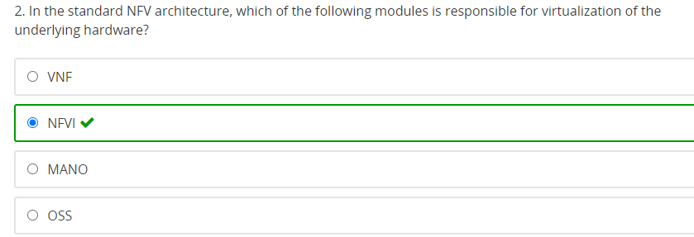

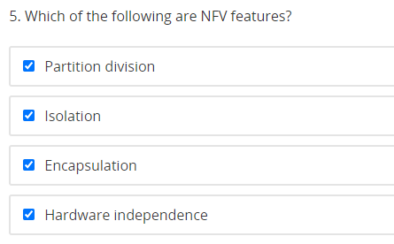

**5) APPLICATION LAYER PROTOCOLS**

**FTP 20|21**

352. When upgrading the router software using the FTP protocol, which transfer mode should be selected?

A. Text mode

B. Byte mode

C. Streaming byte mode

**D. Binary mode**

57. What is the port number used by the FTP protocol control plane?

A.23

B.24

**C.21**

D.22

209. When using FTP for file transfer, how many TCP connections will be established?

**A.2**

B.1

C.3

D.4

**TFTP 69**

1. TFTP uses TCP to transfer files, and the default server port number is 21.

* True
* **False**

**TELNET 23**

26. Which of the following port numbers is used by the Telnet protocol?

A. l7

B. 6

**C. 23**

D. 21

12.After the administrator successfully logs in to the router through Telnet, and finds that the router's interface IP address cannot be allocated, the possible reasons are

**A. The Telnet user level is incorrectly configured**

B. SNMP parameter is incorrectly configured

C. The Telnet user authentication mode is incorrectly configured

D. The administrator uses the telnet terminal software to prohibit the corresponding operation

176. The administrator cannot log in to the Huawei router through Telnet, but other administrators can log in normally, so which of the following are the possible reasons? (Multiple Choice)

A.The authority level of the administrator user account has been modified to 0

**B. The administrator user account has been disabled**

C. The Te1net service of the AR2200 router has been disabled

**D. The administrator user account has been deleted**

56.As shown in the figure below, router A has Telnet router B through IP address 10.0.12.2. In the current interface, which of the following operations will cause the Telnet session of Router A and Router B to be interrupted? (Multiple Choice)

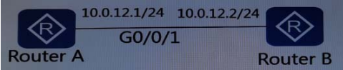

**A. Modify the IP address of G0/0/1 interface**

**B. Close G0/0/1 interface**

C. Configure static routing

D. Enable 0SPF protocol under G0/0/1 interface

**TELNET_LIB**

22.Telnetlib is a module that implements the Telnet protocol that comes with Python.

**A.True**

B.False

114.A device has been configured to complete the Telnet configuration. The device login address is 10.1.1.10. The Telnet username is admin and the password is Huawei@123. Which of the following is the correct way to log in to this device using telnetlib?

A.telnetlib.Telnet（10.1.1.0,23,admin,Huawei@123）

**B.telnetlib.Telnet（10.1.1.0）**

C.telnetlib.Telnet（10.1.1.0,23, Huawei@123）

D.telnetlib.Telnet（10.1.1.0,admin）

374. Which of the following methods can read data non-blocking in Python's telnetlib?

A.telnet_Read_all

B.telnet_read_very_lazy

**C.telnet._read_eager**

D.telnet_read _very_eager

402. The role of telnet.read_all() in Telnetlib is to read all data until EOF. If the echo does not return EOF, it will always be blocked.

**A.True**

B.False

167. Now it is necessary to implement a Python automation script Te1net to the device to view the device running configuration. Which of the following statements is wrong?

A. Telnetlib can achieve this function.

B. Use telnet.Telnet (host) to connect to the Telnet server.

C. can use telnet.write(b"display current-configuration \n") to input the command to view the current configuration of the device.

**D. telnet.c1ose() is used after a command entered every time, the function is that the user waits for the switch to return information.**

**DHCP 67|68**

35. In which of the following modes are DHCP Discover messages sent?

A. Multicast

B. Anycast

C. Unicast

**D. Broadcast**

367. What is the destination IP address of the DHCP DISCOVER message?

A.127.0.0.1

B.224.0.0.1

C.224.0.0.2

**D.255.255.255.255**



11.What percentage does the DHCP client expect to send the lease renewal message for the first time?

**A.0.5**

B.0.875

C.1

D.0.25

162. By default, how long is the lease period of the IP address assigned by the DHCP server?

A.12h

B.1h

**C.24h**

D.18h

242. What are the advantages of using dynamic host configuration protocol DHCP to assign IP addresses? (Multiple choice)

A. Heavy workload and difficult to manage

**B. Reuse of IP address can be realized**

**C. Avoid IP address conflicts**

**D. When the configuration information changes (such as DNS), only the administrator needs to modify it on the DHCP server to facilitate unified management**

298. What is the main function of the DHCP DISCOVER message?

A. The server's confirmation response to the REQUEST message

**B. The client is used to find the DHCP server**

C. The client requests configuration confirmation, or renews the lease

D. The DHCP server is used to respond to the DHCP DISCOVER message, which carries various configuration information

299. Which of the following network parameters can be assigned by Dynamic Host Configuration Protocol DHCP? (Multiple choices)

**A. IP address**

**B. Gateway address**

C. Operating system name

**D. DNS address**

441. What kind of message does the DHCP server use to confirm that the host can use the IP address?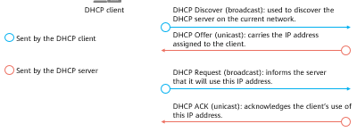

A. DHCP DISCOVER

B. DHCP ACK

**C. DHCP OFFER**

D. DHCP REQUEST

**DNS 53**

267. What is the main function of the DNS protocol?

**A. Domain name resolution**

B. File transfer

C. Remote access

D. Mail transmission

33. The Domain Name System (DNS) protocol is used to resolve domain names to IP addresses. Which of the following statements about DNS is false?

A. A DNS server maintains the database that stores the mappings between domain names and IP addresses and responds to the requests from the resolver.

**B. DNS supports traversal query.**

C. A domain name can be used to identify a host

D. DNS supports recursive query.

11.Mastering the basic operations of the file system is crucial for network engineers to efficiently manage the configuration files and VRP system files of devices. Which of the following statements is true about these files?

A. System software is mandatory for device startup and running. The common file name extension is .cfg.

B. A patch file is a type of software compatible with the system software. The common file name extension is .zip.

C. A configuration file stores configuration commands. The common filename extension is .cc.

**D. A PAF file effectively controls product features and resources. The common file name extension**

* **NTP (Network Time Protocol) 123**

13. NTP is a network protocol used to synchronize computer clocks with an NTP server. Which of the following statements about NTP is false?

A. The stratum indicates the hierarchy for clock synchronization. The value 1 indicates the highest clock precision.

B. NTP packets are transmitted through UDP.

**C. NTP is a network layer protocol in the TCP/IP protocol suite.**

D. The master time server directly synchronizes with the standard reference clock through cables or radio signals.

**7) AAA (Authentication, Authorization, and Accounting)**

1. AAA is short for authentication, authorization, and application.

* True
* **False**

10. On Huawei equipment, if you use aaa authentication for authorization. When the remote server does not respond, you can authorize from the network equipment side.

**A.True**

B.False

42.Which of the following is not included in AAA?

A.Authentication

B.Accounting

C.Authorization

**D.Audit**

43. On Huawei ARG3 series routers, what authentication modes does AAA support? (Multiple Choice)

A.802.1x

**B.Local**

**C.None**

**D.HWTACACS**

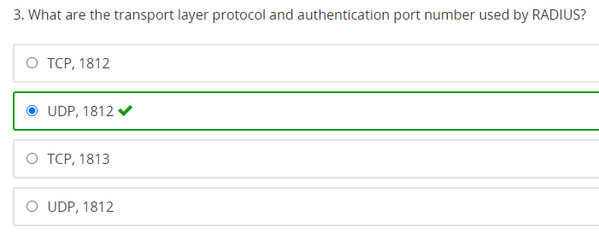

**UDP 1812 for Authentication**

**UDP 1813 for Accounting**

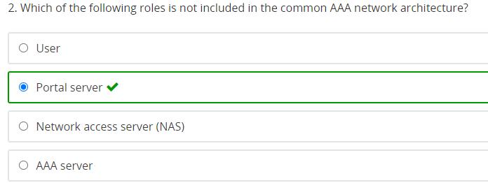

1. Refer to the following AAA configuration on a device. Which of the following statements is true?

[R1-aaaldisplay this

[V200R003C00]

#

aaa

authentication-scheme default

authorization-scheme default

accounting-scheme default

domain default

domain default_admin

local-user huawei password cipher %$%$m]GrHmJ1 mL[7&zCh*^XQBUII]%$%$

local-user huawei privilege level 0

local-user huawei service-type telnet

#

A. The authorization scheme is default and the authorization mode is non-authorization.

**B. The authentication mode is local authentication.**

C. The huawei user can log in to the device through SSH.

D. The huawei user can run the display current-configuration command.

149.The network administrator configures the Huawei router RTA as shown in the figure. If a user needs to be authenticated in the authentication domain "huawei", the correct description below is ().

[RTA]aaa

[RTA-aaa]domain Huawei

RTA-aaa-domain-huawei]authentication-scheme aul

[RTA-aaa-domain-huawei]authentication-scheme au2

**A. "authentication-scheme aul" authentication will be used, if "au1" is deleted, "au2" authentication will be used**

B. Will use "au2" authentication and will use "authentication-scheme au1" authentication

C. Will use "authentication-scheme au2" authentication

D. "authentication-scheme au2" authentication will be used, if "au2" is registered, "aul" authentication will be used

**STP**

412. In a Layer 2 network with redundant links, which of the following protocols can be used to avoid loops?

A. VRRP

B.ARP

C.UDP

**D. STP**

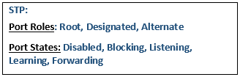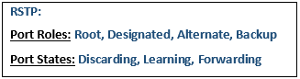

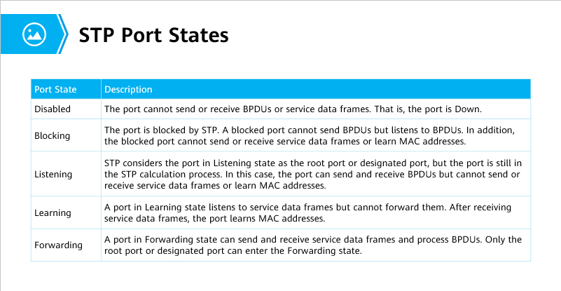

221. The device port running STP protocol is in Forwarding state. Which of the following statements is correct?

**A. The port not only forwards user traffic but also processes BPDU packets.**

B. The port only receives and processes BPDUs, and does not forward user traffic.

C. The port will build a MAC address table based on the received user traffic, but does not forward user traffic.

D. The port not only does not process BPDU packets, but also does not forward user traffic.

330. In which working state of the STP protocol can the port be changed to the Forwarding state without going through other states? 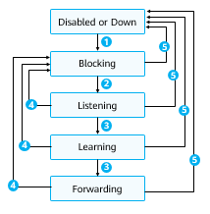

A. Blocking

**B. Learning**

C. Listening

D. Disabled

239. Which of the following port states is not included in the RSTP protocol?

A. Learning

B. Discarding

C. Forwarding

**D. Blocking**

258. Which of the following port states does the RSTP protocol include? (Multiple choice)

**A.Learning**

**B.Discarding**

C.Listening

**D.Forwarding**

259. In the RSTP standard, in order to improve the convergence speed, the port that the switch is directly

connected to the terminal can be defined as ( ).

**A. Edge port**

B. Root port

C. Fast port

D. Backup port

437. Which of the following statements about the edge port in the RSTP protocol is correct?

A. The edge port discards the received configuration BPDU packet

**B. The edge port can be directly transferred from Disable to Forwarding state**

C. Edge port participates in RSTP operation

D. The interconnection ports between switches need to be set as edge ports

261. The Backup ports in RSTP may alternatively failed root port. 

A.True 

**B.False**

20. Which of the following is not a valid port role in RSTP?

**A. Forwarding port**

B. Root port

C. Backup port

D. Designated port

9. In STP, which of the following values cannot be set as the bridge priority?

A.8192

B.16384

C.0

**D.22528**



105. When Huawei switches allow STP, the priority of the switch is by default:

**A.32768**

B.8192

C.16384

D.4096

18. Which of the following statements about BPDUs in STP is false?

A. TCN BPDUs are triggered only when the network topology changes.

B. A configuration BPDU contains parameters such as the bridge ID, path cost, and port ID.

**C. When the network topology becomes stable, all switches proactively send configuration BPDUs.**

D. BPDUs are classified into configuration BPDUs and TCN BPDUs.

28、Which of the following statements about STP and RSTP is false?

 A. There are five STP port states: Forwarding,

Learning, Listening, Blocking, and Disabled.

** B. There are three RSTP port states: Forwarding, Learning, and Blocking.**

 C. RSTP is backward compatible with STP.

 D. RSTP converges faster than STP.

7.By default, the root path cost of the root bridge in the STP protocol must be 0.

**A.True**

B.False

293. Which of the following parameters is not included in the configuration BPDU of the STP protocol?

A. Port ID

**B. VLAN ID**

C.Bridge ID

D.Root ID

410. In the STP protocol, which of the following factors will affect the election of the root switch? (Multiple choice)

A. The IP address of the switch

B. Switch interface ID

C. Switch interface bandwidth port

**D. Switch priority**

**E. MAC address of the switch**

316. By default, what is the STP Forward Delay time in seconds?

A.5

B.10

**C.15**

D.20

257. By default, the port cost calculated by STP has a certain relationship with the port bandwidth, that is, the greater the bandwidth, the () the cost.

A. greater

B. Consistent

C. Not necessarily

**D. smaller**

80.Which of the following is not the reason for RSTP improving the convergence speed?

A. Introduction of edge ports

B. Fast switching of the root port

C. P/A mechanism

**D. Forward Delay canceled**

87.What is the value of the Type field in the RStp configuration BPDU message?

A.Ox01

**B.ox00**

C.ox02

D.ox03

106.As shown in the figure, the switch runs STP with default parameters, which of the following ports will be elected as the designated port?



**A. G0/0/1 port of switch A**

B. Port G0/0/2 of switch A

C. HUB's G0/0/1 port

D. HUB's G0/0/2 port

121.The RSTP protocol uses the P/A mechanism to speed up the speed of the upstream port to the Forwarding state, but what is the reason why there is no temporary loop?

A. Speed up port role election

**B. Through the synchronization mechanism to ensure that no temporary loop occurs**

C. Edge ports are introduced

D. Shorten the time of Forward Delay

126.In standard STP mode, which of the following port of non-root switches will forward the TC set BPDU generated by the root switch?

A. Designated port

**B. Root port**

C. Backup port

D. Preparation port

146. The bridge ID of the STP protocol in the switching network is as follows. Which of the following bridge ID switches will become the root bridge?

**A.4096 00-01-02-03-04-DD**

B.32768 00-01-02-03-04-AA

C.32768 00-01-02-03-04-CC

D.32768 00-01-02-03-04-BB

204. If STP is not turned on for the network composed of switches, there must be a Layer 2 loop.

**A.TRUE**

B.False

**9) VLAN**

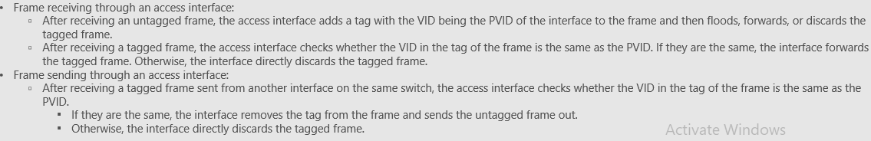

1. After receiving a tagged frame from the peer device, an access port of a switch checks the VLAN ID of the frame. If the VLAN ID is the same as the PVID of this port, the port accepts the frame and removes the tag from the frame.

* True
* **False**

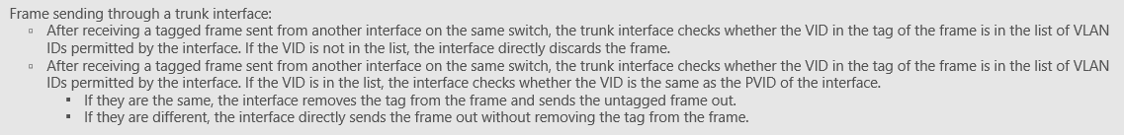

1.When the Trunk port send the data frame, how to deal with it?

**A. When the VLAN ID is the same as the PVID of the port and is a VLAN ID allowed by the port, remove the Tag and send the message**

B. When the VLAN ID is different from the PVID of the port, the data frame is dropped

C. When the VLAN ID is different from the PVID of the port, replace it with PVID forwarding

D. When the VLAN ID is different from the PVID of the port, strip off the TAG and forward

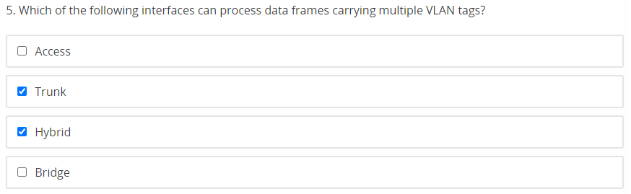

27. Which is the most widely used VLAN assignment method?

1. IP subnet-based VLAN assignment

**B. Interface-based VLAN assignment.**

C. Protocol-based VLAN assignment

D. MAC address-based VLAN assignment

2.How many bits are there in the VLAN ID in the VLAN format defined by IEEE802.1Q?

**A.12** 

B.6

C.10

D.8

88. The Priority field in the VLAN tag can identify the priority of the data frame. What is the range of this priority?

A.0-15

B.0-63

C.0-3

**D.0-7**

224. What is the total length of the VLAN frame format defined by IEEE802.1Q?

A. 1

B. 2

C. 3

**D. 4** 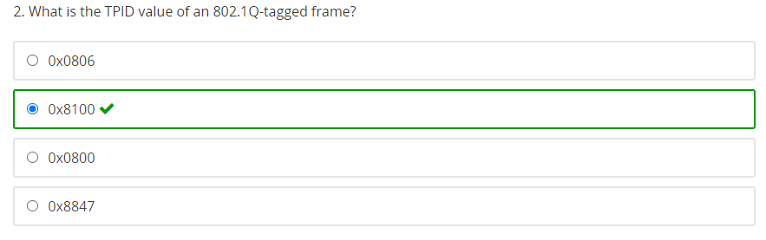

183. If the Length/Type of an Ethernet data frame = 0x8100, which of the following statements is correct?

A. There must be an IP header in the upper layer of this data frame 

**B. This data frame must carry VLAN TAG**

C. There must be a UDP header in the upper layer of this data frame

D. There must be a TCP header in the upper layer of this data frame

328.What is the role of the command port trunk allow pass vlan all?

A. If the port default vlan 3 command is configured for the connected remote device, VLAN 3 cannot communicate between the two devices

**B. All VLAN data frames are allowed to pass through this port**

C. The connected peer device can dynamically determine which VLAN IDs are allowed to pass

D. The opposite port connected to the port must be configured with port trunk permit vlan all

393. On the switch, which VLANs can be deleted by using the undo command? (Multiple choice)

**A.vlan 4094**

**B.vlan 2**

C.vlan 1

**D.vlan 1024**

12.The vlan batch 4 10 command is use to create VLAN 4 and VLAN 10

** True**

** False**

6.The number of VLANs that can be created using the commands "vlan batch 10 20" and "vlan batch 10 to 20" respectively is

A.11 and 11

B.11 and 2

C.2 and 2

**D. 2 and 11**

39.The network administrator created VLAN 10 on the Layer 3 switch and configured an IP address under the virtual interface of the VLAN. When the command "display ip interface brief" is used to check the port status, it is found that the VLANIF 10 interface is in the down state. What should be done to restore the VLANIF 10 interface to normal?

A. Add an interface that must be Up and must be of type Trunk into VLAN 10

B. Assign any physical interface to VLAN 10

C. Assign a physical interface that must be Up to VLAN 10

**D. Use the command "undo shutdown" under VLANIF 10 interface**

34. Refer to the following configuration on a switch:

[huawei]vlan batch 2 to 9 10

Which of the following statements is true about this command?

A. The command is incorrect. As a result, the VRP will report an error when this command is run.

B. VLANs 2, 9, and 10 will be created on the switch.

C. VLANs 2 through 9 10 will be created on the switch.

**D. VLANs 2 to 10 will be created on the switch.**

34. Using the commands "vlan batch 10 20" and "vlan batch 10 to 20", how many VLANs can be created respectively?

A. 11 and 11

B. 2 and 2

C. 11 and 2

**D. 2 and 11**

84. The switch GO/0/1 port configuration information is shown in the figure. Which VLAN data frame does the switch forward without VLAN TAG?

#

interface GigabitEtherneto/o/1

port link-type trunk

port trunk pvid vlan 10

port trunk allow-pass vlan 10 20 30 40

#

**A.10**

B.30

C.20

D.40

50、Which of the following are the advantages of a VLAN?

** A. Enhances LAN security.**

** B. Flexibly constructs virtual workgroups.**

** C. Improves network robustness.**

** D. Limits broadcast domains.**

143.What are the following characteristics of the default VLAN in the Layer 2 Ethernet switch? (Multiple Choice)

**A. The default VLAN cannot be deleted manually**

**B. By default, all ports of the switch are member ports of the default VLAN**

C. A default VLAN must be created before it can be assigned a port

**D. The IP address configured on the switch will only be applied to the member ports of the default VLAN**

203. Which of the following advantages does router-on-a-stick achieve inter-VLAN routing intercommunication?

A. Reduce the number of equipment

B. Reduce the use of IP addresses

**C. Reduce the number of link connections**

D. Reduce routing table entries

122.Which of the following statements about router-on-a-stick are correct? (Multiple Choice)

**A. Use only one physical link connection between the switch and the router**

**B. Need to create a sub-interface on the router**

C. One physical connection per VLAN

**D. On the switch, configure the port connected to the router as a Trunk port, and allow frames of the relevant VLAN to pass**

39. What is the valid VLAN ID range?

1. 0 to 4095
2. 0 to 4094
3. 1 to 4095
4. **1 to 4094**

1、The PVID of a trunk port on a switch may not be the ID of a VLAN that is allowed for the

port.

** True**

** False**

81. The IP addresses of the VLANIF interfaces of the same switch cannot be the same.

**A.True**

B.False

**6) NETWORK MANAGEMENT O&M**

69.Which planes of the following does a network device have? (Multiple choice)

**A. Control plane**

B. Business plane

**C. Data plane**

D. Management plane

* **MIB(Management Information Base)**

166. MIB (Management Information Base) is a virtual database that exists only in NMS. 

A.True

**B.False**

* **SNMP**

101.SNMP is a standards-based network management protocol widely used on TCP/IP networks. It provides a method for points, managing NEs through a central computer that runs network management software, that is, a network management station (NMS). An SNMP NMS and SNMP agent communicate with each other through the TCP protocol.

* True
* **False**

109.Which statement about SNMP protocol is correct?

**A. SNMP uses UDP as the transport layer protocol**

B. SNMP uses ICMP as the network layer protocol

C. SNMP protocol uses multicast to send management messages

D. The SNMP protocol only supports the sending of flash management messages on the Ethernet link

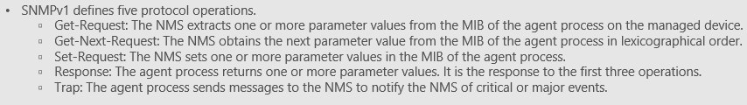

66.SNMPv1 defines 5 protocol operations.

**A.True**

B.False

341. The network management workstation manages network equipment through the SNMP protocol. When an abnormality occurs in the managed device, what kind of SHMP message will the network management workstation receive?

**A. trap message**

B. get-response message

C. set-request message

D. get-request message

19.Which of the following SNMP packets are sent to the NMS by the Agent on the managed device?

A.Set-Request

B.Get-Request

C.Get-Next-Request

**D.Response**

49、In contrast with SNMPv1, which of the following operations are newly added to SNMPv2c?

 A. GetNextRequest

** B. InformRequest**

** C. GetBulkRequest**

 D. SetRequest

65. Which version of the SNMP protocol below supports encryption features?

**A.SNMPv3**

B.SNMPv2c

C.SNMPv1

D.SNMPv2

196. Huawei ARG3 series routers have all SNMP versions (SNMPv1, SNMPv2c and SNMPv3) by default.

**A.True**

B.False

371. Network equipment running the SNMP protocol can take the initiative to report alarm information so that the network administrator can discover the fault in time.

**A.True**

B.False

55.By default, in the SNMP protocol, which port number does the agent process use to send alarm messages to NS? 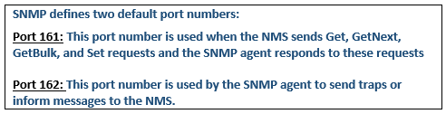

A.164

B.163

**C.162**

D.161

304. The network management system can only view the operating status of the device through the SNMP protocol, but cannot issue configurations.

A. True

**B. False**

* **TELEMETRY**

1. The precision of telemetry-based traffic statistics collection can be measured in milliseconds.

* True
* **False**

**Correct: subseconds**

* **NETCONF**

24. The Network Configuration Protocol (NETCONF) provides a mechanism for managing network devices. Which of the following statements about NETCONF is false?

A. If YANG files are not integrated into a device, the device does not support NETCONF.

**B. NETCONF messages are formatted using either JSON or XML.**

C. Yet Another Next Generation (YANG) is a data modeling language that standardizes NETCONF data content.

D. NETCONF supports trial runs and rollback in case of errors.

**NETWORK LAYER PROTOCOL**



136. If the transport layer protocol is UDP, the value of the network layer Protocol field is 6. 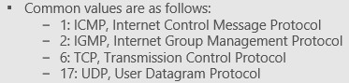

A.True

**B.False**

* **IP ADDRESSING**

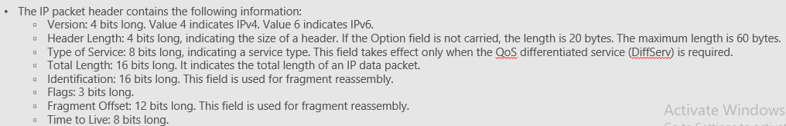

361. When the IPv4 protocol is used as the network layer protocol, which field is not included in the 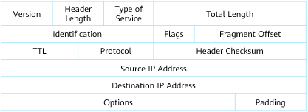

network layer header?

A. Source IPv4 address

**B. Sequence number**

C. Destination IPv4 address

D. TTL

33.Which of the following cannot be the length of the IPv4 packet header?

A.32B

B.60B

C.20B

**D.64B**

101. Which fields in the IPv4 header are related to fragmentation? (Multiple Choice)

A.TTL

**B.Fragment Offset**

**C.Identification**

**D.Flags**

118.Which of the following IPv4 addresses the host uses cannot directly access the Internet?

A.100.1.1.1

B.50.1.1.1

**C.10.1.1.1 (private address)**

D.200.1.1.1

190. Which of the following IPv4 addresses can be used by a host to directly access the Internet?

A.192.168.1.1/24

**B.172.32.1.1/24**

C.172.16.255.254/24

D.10.255.255.254/24

454. After the network administrator uses the TracertRoute function on the router device, in the data packet sent by the router, what is the value of the Protocol field in the IPv4 header?

A.17

B.2

C.6

**D.1**

137.If the application layer protocol is Telnet, what is the value of the Protocol field in the IPv4 header?

**A.23**

B.17

C.6

D.67

155. The IPv4 address assigned by the network administrator to a host in the network is 192.168.1.1/28. How many hosts can be added to the network where this host is located?

A.12

B.15

C.13

**D.14 (32-28=4, 24 = 16 - 2= 14)**

* **ICMP**

36、When a ping command is run on a network device to check the network connectivity, which type of packet will be sent by the network device?

 A. TCP

 B. UDP

 C. IGMP

** D. ICMP**

40. The ping and tracert commands are used to check the network status. Which of the following statements about the ping and tracert commands is false?

A. The source IP address of packets to be sent can be specified in the tracert command.

B. The tracert command can be used to check the gateways that packets pass through before reaching the destination.

**C. The ping -s source-ip-address destination-ip-address command is used to specify the source and destination IP addresses of ICMP Echo Request packets.**

D. The ping command can be used to check connectivity to a destination address.

449. Which of the following statement about the TTL field in the IP packet header is correct?

A. TTL defines the time interval at which the source host can send data packets

B. TTL defines the number of packets that the source host can send

**C. Every time an IP packet passes through a router, its TTL value will be reduced by 1**

D. Each time an IP packet passes through a router, its TTL value will be increased by 1

**IPV6**

271. Which of the following types does IPv6 address contain? (Multiple choice)

**A. Unicast address**

B. Broadcast address

**C. Multicast address**

**D. Anycast address**

20.Which field is added to the IPv6 packet header than the IPv4 packet header?

A.Destination Address

**B.Flow Label**

C.Version

D.Source Address

306. Which extension headers are supported by IPv6 packets? (Multiple choice)

**A. Destination option extension header**

**B. Fragmentation extension header**

**C. Hop-by-hop option extension header**

D. VLAN extension header

21.Which of the following statements about RA and RS in IPv6 are correct? (Multiple Choice)

A. RS is used to reply address prefix information

B. RA is used to request address prefix information

**C. RS is used to request address prefix information**

**D. RA is used to reply address prefix information**



111. Which of the following messages are used for IPv6 stateless address auto configuration? (Multiple Choice)

A.NS

**B.RA**

C.NA

**D.RS**

372.The IPv6 protocol uses NS and NA packets for duplicate address detection (DAD).

**A.True**

B.False

273. Which of the following protocols does the RA message used by IPv6 stateless autoconfiguration belong to?

A.IGMPv6

**B.ICMPv6**

C.UDPv6

D.TCPv6

113.Which of the following statements about IPv6 address configuration are correct? (Multiple Choice)

**A. IPv6 supports stateless automatic configuration**

**B. IPv6 address supports automatic configuration in multiple ways**

**C. IPv6 supports DHCPv6 for address configuration**

D. IPv6 address can only be configured manually

60. The basic header length of IPv6 packets is a fixed value.**(40 bytes)**

**A.True**

B.False

214. Which field of the ipv6 packet header can be used for QoS?

**A.Traffic Class**

B.Payload Length

C.Version

D.Next Header

12. Before sending an IPv6 packet, an interface performs the following operations in this order: address configuration, address resolution, and duplicate address detection (DAD).

* True
* **False**

114.An IPv6 address is 128 bits long. Typically, an IPv6o address is represented by eight groups of 16-bit hexadecimal values separated by colons (:). Which of the following statements about IPv6 addresses is false?

A. There may be ULA conflicts in a global scope.

B. A global unicast address (GUA) is globally unique.

**C. Each IPv6 interface must have a unique local address (ULA).**

D. The IPv6 address with the prefix FE80::/10 is a link-local address (LLA).

342. What type of IPv6 address FE80: 2E0: FCFF: FE6F: 4F36 belongs to? 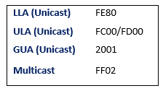

A. Multicast address

**B. Link local address**

C. Global semicast address

D. Anycast address

424. Which of the following IPv6 is a global unicast address?

**A.2001::12:1**

B.FF02::1

C.FF::02::2E0:FCFF:FEEF:FEC

D.FEE:FCFF:FEEF:FEC

112. Which of the following IPv6 addresses is a multicast address?

A.FE80：：2E0：FCFF：FEEF：FEC

B.FC00：：2E0：FCFF：FEEF：FEC

**C.FF02：：2E0：FCFF：FEEF：FEC**

D.2000：：2E0：FCFF：FEEF：FEC

423.,:: 1/128 is the IPv6 loopback address.

**A. True**

B. False

347. If the MAC address of an interface is 0OEO-FCEF-OFEC, what is its corresponding EUI-64

address?

A.00EO-FCEF-FFFE-OFEC

**B.02EO-FCFF-FEED-0FEC**

C.00EO-FCFF-FEED-0FEC

D.02EO-FCEF-FFFE-0FEC

67.The IPv6 address 2001: ABEF: 224E: FFE2: BCC0: CD00: DDBE: 8D58 cannot be abbreviated.

**A.True**

B.False

272. Regarding the IPv6 address 2031:0000:720C:0000:0000:09E0:839A:130B, which of the following abbreviations is correct?

A.2031:0:720C:0:0:9E:839A:130B

**B.2031:0:720C::9E0:839A:130B**

C.2031:0:720C:0:0:9E0:839A:130B

D.2031::720C::9E0:839A:130B

**ACL**

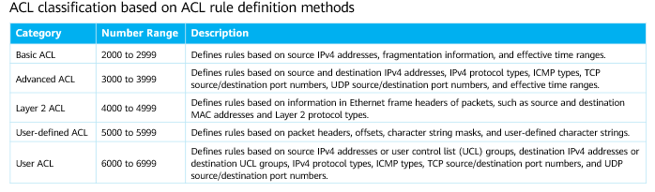

59、ACLs are used to match and distinguish packets. Which of the following information can be used to define ACL rules?

** A. Source and destination MAC addresses**

** B. Protocol type of Ethernet frames**

** C. VLAN ID**

** D. Source and destination IP addresses of IPv4 packets**

Refer to the following ACL configuration on a device. Which of the following statements is true? # time-range satime 08:00 to 17:30 working-day # acl number 3002 rule 5 permit ip source 10.164.2.0 0.0.0.255 destination 10.164.9.9 0.0.0.255 time-range satime

1. This ACL is a user ACL according to the ACL classification rules.
2. All packets with the source IP addresses on the network segment 10.164.2.0/24 will be permitted by the device.
3. This ACL is a basic ACL according to the ACL classification rules.
4. **The ACL rule takes effect only on working days.**

159. What is the number range of advanced ACL?

**A.3000-3999**

B.2000-2999

C.4000~～4999

D.6000~6031

Which of the following parameters can be specified when an administrator configures an advanced ACL?

1. **ICMP protocol type**
2. **Source and destination IP addresses**
3. **Source and destination port numbers**
4. Source and destination MAC addresses

263. If the largest number in an ACL rule is 12, by default, the user does not specify a number when configuring a new rule, then what is the number assigned by the system for the new rule?

A.13 

**B.15**

C.14

D.16

**2) IP ROUTING**

1.Specific routes can be summarized into a summary route only when they have the same next hop address

* **True**
* False

12. During IP packet forwarding, the last-hop router forwards packets using the direct route.

* **True**
* False

73.Which of the following statements about direct routing is correct?

A. Direct routing requires the administrator to manually configure the destination network and the next-hop address

B. Direct route has lower priority than static route

C. Direct route priority is lower than dynamic route

**D. Direct routing has the highest priority**

53.Which of the following statements about static and dynamic routes are true?

A. When creating a static route, you must specify both the outbound interface and next hop.

**B. Dynamic routing protocols can automatically discover and generate routes and are more suitable for large-scale networks.**

**C. Dynamic routing protocols can be classified into distance-vector routing protocols and link-state routing protocols based on their working mechanism and routing algorithms.**

**D. Static routes have low requirements on the system and are applicable to simple, stable, and small-sized networks.**

58.The route preference is an indicator used by a router to compare routes of different routing protocols. Which of the following statements are true about the default preference of common routes?

A. The default preference of an OSPF external route is 255.

**B. The default preference of a static route is 60.**

**C. The default preference of a direct route is 0.**

**D. The default preference of an OSPF internal route is 10.**

97.On the VRP platform, the default protocol priority of routes in the direct routing, static routing, RIP, OSPF area is:

**A. Direct routing,OSPF,Static routing,RIP**

B. Direct routing,Static routing,RIP,OSPF

C. Direct routing,RIP,Static routing,OSPF

D. Direct routing,OSPF,RIP,Static routing

* **STATIC ROUTES**

1. Static routes and OSPF routes can form equal-cost routes.

* True
* **False**

32. A router has the following four specific routes:

ip route-static 10.1.20,0 24 12.1.1.2

ip route-static 10.1.21.0 24 12.1.1.2

ip route-static 10.1,22.0 24 12.112

ip route-static 10.1.23,0 24 12.1.1.2

To summarize these specific routes, which of the following commands should be run?

A. ip route-static 10.1.0.0 16 12.1.1.2

**B. ip route-static 10.1.20.0 22 12.1.1.2**

C. ip route-static 10.1.16.0 21 12.1.1.2

D ip route-static 10.1.20.0 23 12.1.1.2

12. When two static routes work as the primary and backup routes, the preference of the backup route can be changed to the same as that of the primary route so that the two routes become equal-cost routes.

* **True**
* False

35.In the network shown in the figure below, if Router A and Router B's loopback 0 communicate through static routing, which command needs to be entered on Router A?

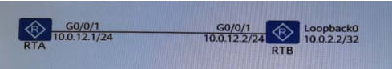

A.ip route-static 10.0.2.2 0 GigabitEthernet 0/0/0

B.ip route-static 10.0.2.2 32 GigabitEthernet 0/0/0

C.ip route-static 10.0.2.2 255.255.255.255 10.0.12.1

**D.ip route-static 10.0.2.2 255.255.255.255 10.0.12.2**

49.Which of the following statement about static routing in Huawei equipment is wrong?

A. The cost value (Cost) of the static route cannot be modified.

B. The default value of the static route priority is 60

**C. The range of the static route priority value is 1-255**

D. When the priority of the static route is 0, the route will definitely be preferred.

140. VRP operating platform, which of the following commands can only view static routes?

A.display ip routing-table statistics

B.display ip routing-table verbose

C.display ip routing-table

**D.display ip routing-table protocol static**

142.ip route-static 10.0.2.2 255.255.255.255 10.0.12.2 preference 20. Which is correct about this command? (Multiple Choice)

**A. The NextHop of this route is 10.0.12.2**

**B. The priority of this route is 20**

**C. This route can guide the forwarding of packets with the destination IP address 10.0.2.2.**

D. This route can guide the forwarding of packets with the destination IP address 10.0.12.2

170. The administrator plans to implement route backup by configuring static floating routes, what is the correct way to achieve this?

A. The administrator needs to configure different metric values for the main static route and the standby static route

B. The administrator needs to configure different TAGs for the main static route and the standby static route

C. The administrator only needs to configure two static routes

**D. The administrator needs to configure different protocol priority values for the main static route and the standby static route**

188. Which of the following statement about static routing is wrong?

A. Cannot automatically adapt to changes in network topology

B. Manual configuration by the network administrator

C. Low system performance requirements

**D. Routers need to exchange routing information**

189. In the network shown in the figure below, which of the following commands can be entered on the router to enable host A to ping host B? (Multiple choice)

1. **RTA: ip route-static 10.0.12.5 255.255.255.252 11.0.12.2**

**RTB: ip route-static 10.0.12.1 255.255.255.252 11.0.12.1**

1. RTA: ip route-static 10.0.12.5 255.255.255.252 11.0.12.1

RTB: ip route-static 10.0.12.1 255.255.255.252 11.0.12.2

1. **RTA: ip route-static 0.0.0.0 0.0.0.0 11.0.12.2**

**RTB: ip route-static 0.0.0.0 0.0.0.0 11.0.12.1**

1. RTA: ip route-static 0.0.0.0 0.0.0.0 11.0.12.1

RTB: ip route-static 0.0.0.0 0.0.0.0 11.0.12.2

322. Among the following commands to configure the default route, which one is correct?

A.[Huawei-Seria10] ip route-static 0.0.0.0 0.0.0.0 0.0.0.0

**B.[Huawei] ip route-static 0.0.0.0 0.0.0.0 192.168.1.1**

C.[Huawei] ip route-static 0.0.0.0 0.0.0.0 0.0.0.0

D.[Huawei] ip route-static 0.0.0.0 255.255.255.255 192.168.1.1

280. The network shown in the figure below. The administrator hopes that RTA uses static routing, and preferentially sends data packets to RTB 's Loopback0 interface through G0/0/1 por, while G0/0/2 serves as a backup. So how to configure RTA to achieve this requirement?

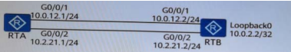

1. ip route-static 10.0.2.2 255.255.255.255 10.0.12.2

ip route-static 10.0.2.2 255.255.255.255 10.0.21.2 preference 40

1. ip route-static 10.0.2.2 255.255.255.255 10.0.12.2 preference 70

ip route-static 10.0.2.2 255.255.255.25510.0.21.2

1. ip route-static 10.0.2.2 255.255.255.255 10.0.12.2

ip route-static 10.0.2.2 255.255.255.255 10.0.21.2

1. **ip route-static 10.0.2.2 255.255.255.255 10.0.12.2**

**ip route-static 10.0.2.2 255.255.255.255 10.0.21.2 preference 70**

406.ip route-static 10.0.12.0 255.255.255.0 192.168.1.1, which description about this command is correct?

**A. This command configures a route to the 10.0.12.0 network**

B. The priority of this route is 100

C. If the router learns a router with the same destination network as this route through other protocols, the router will prefer this route

D. This command configures a route to the 192.168.1.1 network

* **DYNAMIC ROUTES**

28. Dynamic routing protocols can be classified into Interior Gateway Protocol (IGP) and Exterior Gateway Protocol (EGP) according to their working area. Which of the following protocols is an EGP?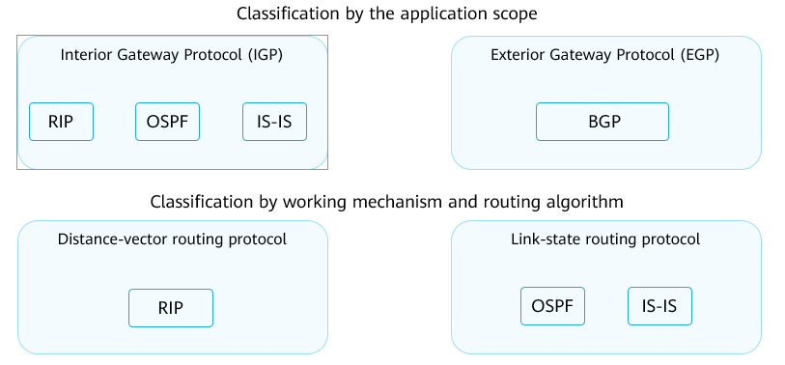

A. OSPF

B.IS-IS

C. RIP

**D. BGP**

220. What is the main function of the dynamic routing protocol?

A. Manage routers

B. Generate IP address

**C. Dynamically generate routing entries**

D. Control router interface status

* **OSPF**

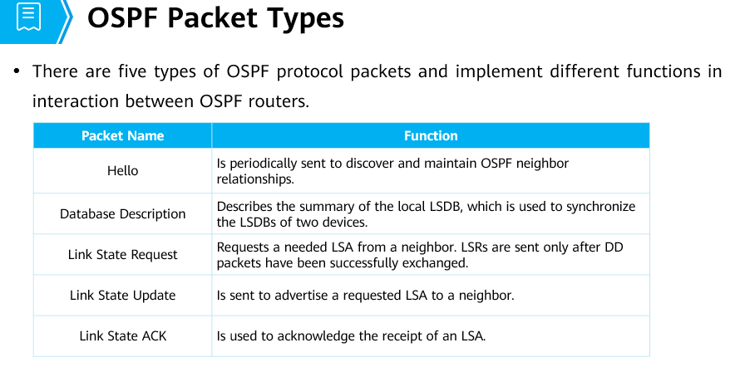

16. Which of the following packet types is used by OSPF to maintain neighbor relationships?

1. LSU
2. DD
3. LSR
4. **Hello**

|  |
| --- |
| 11. OSPF has multiple types of protocol packets. These packets play different roles in the interaction between OSPF routers. Which of the following packets describes summary information about the local LSDB and is used to synchronize the LSDBs of two routers? |
|  |
| A.LSU packet |
| B. DD packet |
| C. Hello packet |
| D.LSR packet |

12. In an OSPF AS, a router can function as both an ABR and an ASBR.

* + **True**
  + False

19. The following shows the routing table of a specific router:

**Destination/Mask Proto Pre Cost Flags NextHop Interface**

172.16.1.0/24 OSPF 10 200 D 192.168.1 Gigabit&thernet0/0/0

172.16.0.0/16 Static 5 0 RD 192.168.1.2 GigabitEthernet0/0/0

172.16.1.0/22 Static 89 0 RD 192.168.1.2 GigabitEthernet0/0/0

When data needs to be sent to the destination 172.16.1.1 through this router, which of the following routes is used?

A Static route 172.16.0.0/16 with a preference of 5 and cost of 0

B. Both static routes because their cost values are the same

C. Static route 172.16.1.0/22 with a preference of 80 and cost of 0

**D. OSPF route 172.16.1.0/24 with a preference of 10 and cost of 200**

23. Which of the following commands can be used to check OSPF LSDB information on a Huawei device?

A. display ospf routing

B. display ospf peer

**C. display ospf lsdb**

D. display ospf brief

31. In the same Ethernet network segment, five routers are running OSPF for interconnection. When the protocol status of all routers is stable, which of the following statements is true?

A. There are routers of which all neighbor relationships are in 2-way state on the network.

B. The neighbor relationship between a DR router and another router can be Full or 2-way.

C. The neighbor status of all routers is Full.

**D. The neighbor status of a router on the network can only be Full or 2-way.**

38. The following shows partial OSPF neighbor information for a specific router:

OSPF Process 1 with Router ID 10.1.1.3

Neighbors

Area 0.0.0.0 interface 10.1.1.3(GigabitEthernet0/0/0)'s neighbors.

Router ID: 10.1.1.1 Address: 10.1.1.1

State: Full Mode:Nbr is Slave Priority: 1

DR: 10.1.1.5 BDR: 10.1.1.1 MTU: 0

Dead timer due in 35 sec

Retrans timer interval: 5

Neighbor is up for 00:02:01

Authentication Sequence: [ 0]

A. The router is a DR-other router.

**B. The router is the slave router in the master-slave relationship.**

C. The preceding information is about the neighbor relationship of the router and BDR router.

D. The router ID of the OSPF process on the router is 10.1.1.3.

18、The establishment of an OSPF adjacency between devices involves four steps. Which of the following statements about these steps is true?

** A. The devices establish bidirectional neighbor relationships, negotiate the master/slave relationship, exchange LSAs, update LSAs, and synchronize their LSDBs.**

 B. The devices negotiate the master/slave relationship, exchange LSAs, establish bidirectional neighbor relationships, update LSAs, and synchronize their LSDBs.

 C. The devices exchange LSAs, negotiate the master/slave relationship, establish bidirectional neighbor relationships, update LSAs, and synchronize their LSDBs.

 D. The devices negotiate the master/slave relationship, establish bidirectional neighbor relationships, exchange LSAs, update LSAs, and synchronize their LSDBs.

In OSPF, which of the following network types require the election of a DR and BDR?

1. **BMA**
2. P2P
3. **NBMA**
4. P2MP

19、OSPF is configured on RTA, RTB, and RTC. GigabitEthernet 0/0/0 interfaces of these routers belong to area 0 and the network types of these interfaces are broadcast. The router ID of RTA is 1.1.1.1, and the DR priority of GigabitEthernet 0/0/0 on RTA is set to 0. The router ID of RTB is 2.2.2.2, and the DR priority of GigabitEthernet 0/0/0 on RTB is set to 255. The router ID of RTC is 3.3.3.3, and the DR priority of GigabitEthernet 0/0/0 on RTC is the default value. Which of the following statements is true about the DR and BDR on the network?

 A. RTB functions as the DR, and RTA as the BDR.

 B. RTC functions as the DR, and RTB as the BDR.

 C. RTB functions as the DR, and RTC as the BDR.

 D. RTA functions as the DR, and RTB as the BDR.

34.In the network shown in the figure below, all links are Ethernet links, and all interfaces of all routers run OSPF protocol, how many DRs are elected in the entire network?

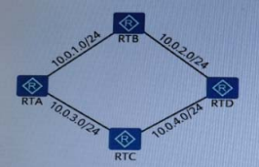

**A.4** **(total 4 networks)**

B.1

C.3

D.2

48.In the network shown in the figure below, all routers run OSPF protocol. Above the link is the value of the Cost value, then the path for RTA to reach the network 10.0.0.0/8 is:

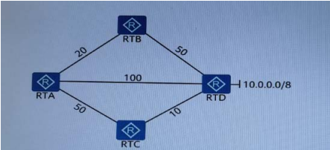

A.A-B-D

B.RTA cannot reach 10.0.0.0/8

**C.A-C-D**

D.A-D

72.Which of the following description about the Router ID of OSPF is incorrect? (Multiple Choice)

**A. Router ID must be the IP address of an interface on the router**

**B. The prerequisite for the normal operation of the OSPF protocol is that the router has a Router ID**

**C. The Router ID must be manually configured**

**D. The Router ID must be the same in the same area, and the Router ID in different areas can be different**

74.What are the advantages of the OSPF protocol? (Multiple Choice)

**A. Division of support areas**

**B. OSPF supports load sharing for equal-cost routes**

**C. OSPF supports message authentication**

**D. OSPF supports type-less inter-domain routing (CIDR)**

78. What are the network types supported by the OSPF protocol? (Multiple Choice)

**A.Point-to-Point**

**B.Non-Broadcast Multi-Access**

**C.Point-to-Multipoint**

**D.Broadcast**

99. On Huawei routers, what is the default value of the OSPF protocol internal routing priority?

A.20

**B.10**

C.30

D.0

117.In the OSPF broadcast network, which routers will a Dothter router exchange link state information with? (Multiple Choice)

**A. BDR**

B. All OSPF neighbors

C. DR Other

**D. DR**

38.Which of the following states indicates that the neighbor relationship is stable between OSPF-enabled DR-other routers on a broadcast network?

 A. Down

 B. Full

 C. Loading

** D. Two-way**

29.In the network shown in the figure below, assuming that all routers enable the OSPF protocol at the same time, which router is the BDR in this network?

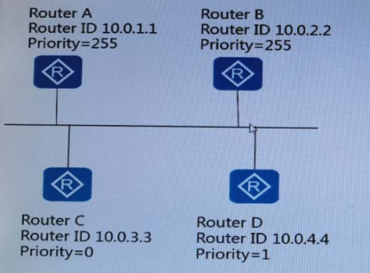

A.Router D

B.Router B

C.Router C

**D.Router A**

56、Which of the following statements about OSPF router IDs are true?

☞ A. A device uses the smallest IP address configured on loopback interfaces as its router ID. If no loopback interface is configured, the device uses the smallest IP address configured on interfaces as its router ID.

** B. The router ID of every device in an OSPF area**

**must be unique.**

** C. To ensure protocol stability, it is recommended**

**that the network administrator manually configure a**

**router ID for an OSPF process.**

** D. A router ID can be manually configured or**

**automatically selected by a device.**

**8) SWITCHING**

145.On which layer of the OSI reference model does the Ethernet switch work?

A. Network layer

**B. Data link layer**

C. Physical layer

D. Transport layer

1. Frames transmitted on the trunk link between switches are all tagged.

* True
* **False**

15. How many bytes does an MPLS (**Multiprotocol Label Switching)** label contain?

1. **4 bytes**
2. 3 bytes
3. 2 bytes
4. 1 byte

52.Which of the following description about the Layer 2 Ethernet switch is incorrect?

**A. It is necessary to make certain modifications to the layer 3 header of the forwarded message, and then forward it**

B. Able to learn MAC address

C. Forward according to the Layer 2 header information of the Ethernet frame

D. Layer 2 Ethernet switches work at the data link layer

6、A hybrid port on a switch can connect to either a user host or a port on another switch.

** True**

** False**

* **MAC ADDRESS**

25. The MAC address table of a switch is as follows:

00-01-02-03-04-AA GO/0/1

00-01-02-03-04-CC GO/0/3

A data frame with the destination MAC address 00-01-02-03-04-BB is received on GO/0/1, and another data frame with the destination MAC address 00-01-02-03-04-CC is received on GO/0/3. How does the switch process the two data frames?

A Forwards the first frame and floods the second frame.

B. Forwards the first frame and discards the second frame.

C. Floods the first frame and forwards the second frame.

**D. Floods the first frame and discards the second frame.**

44、Which of the following statements about IP addresses and MAC addresses are true?

** A. MAC addresses are assigned based on vendors.**

** B. IP addresses are assigned based on the network topology.**

 C. IP addresses are unchangeable.

** D. MAC addresses are unchangeable.**

326.In the switch MAC address table, which of the following entries will not age?

A. Dynamic MAC address table entry

**B. Static MAC address table entry**

C. Port MAC address table entry

D. Device MAC address table entry

350. The Layer 2 Ethernet switch generates entries in the MAC address table according to the ( ) of the Ethernet frame received by the port.

A. Source IP address

**B. Source MAC address**

C. Destination MAC address

D. Destination IP address

NAT

1. Network Address Translation (NAT) translates the IP address in an IP packet header into another IP address. Which of the following is not an advantage of NAT?

A. Effectively preventing attacks from external networks and greatly improving network security

B. Alleviating the exhaustion of IP addresses

**C. Implementing accurate identification and control of packet flows on networks to control network access behavior, prevent network attacks, and improve network bandwidth efficiency**

D. Allowing the access of intranet hosts to external networks and the access of external hosts to intranets, and enabling communication between intranets and external networks

41、Which of the following IP addresses are private IP addresses?

 A. 172.33.1.1/30

** B. 10.0.1.1/30**

** C. 172.16.1.1/30**

** D. 192.168.1.1/30**

43、Network Address Translation (NAT) translates the IP address in an IP packet header into another IP address. Which of the following methods can implement NAT?

** A. Static NAT/NAPT**

** B. Easy IP**

** C. NAT Server**

** D. Dynamic NAT**

ETHERNET FRAMES

|  |
| --- |
| 1. What is the length range of an Ethernet frame? |
|  |
| A.46to 1518 bytes |
| **B.64 to 1518 bytes** |
| C.46 to 1500 bytes |
| D. 64 to 1500 bytes |

2、To prevent out-of-order packets, it is recommended that Eth-Trunk use flow-based load balancing.

** True**

 False

10、As every two nodes in a full-mesh network are connected using cables, each node requires a large number of physical ports and connection cables, resulting in relatively high costs.

** True**

 False

33、Which of the following statements about edge ports is false?

 A. It takes 15 seconds for an edge port to change from the Disabled state to the Forwarding state.

 B. In most cases, edge ports are directly connected to user terminals.

 C. If an edge port receives a configuration BPDU, it becomes a common STP port.

 D. In normal situations, an edge port cannot receive configuration BPDUs.

7、Segment routing (SR) provides an innovative traffic steering method. It divides a network path into segments and allocates segment IDs (SIDs) to these segments. The segments and nodes are sequentially arranged into a segment list to form a forwarding path.

** True**

 False

Segment routing (SR) can be deployed with or without controllers.

** True**

 False